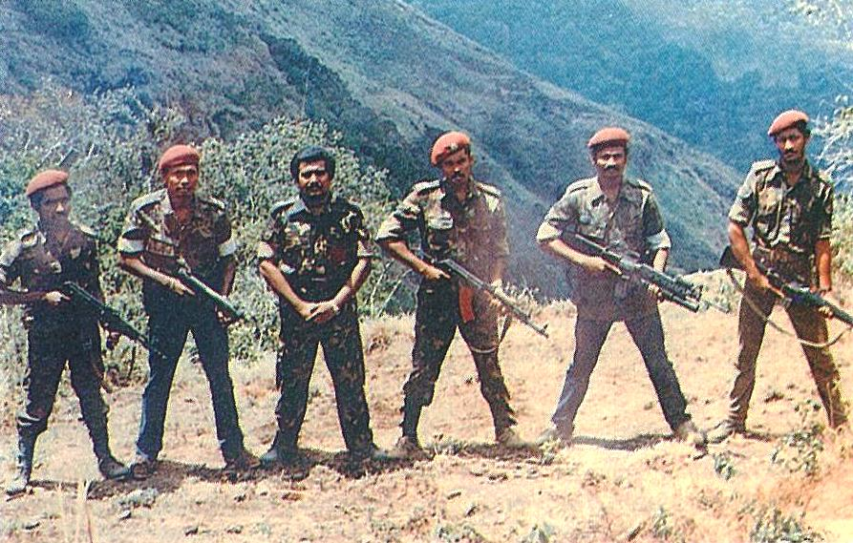 FIG. 1 – LTTE commanders at Sirimalai Camp in northern India – From R. Gunaratna, 1997. For more details. see TPS. Pictorial, p. 61.
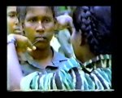 FIG. 2 – A necklace with a cyanide capsule or kuppi, is placed around the neck of a Tigress at the induction ceremony marking her passing out – BBC documentary 1991.
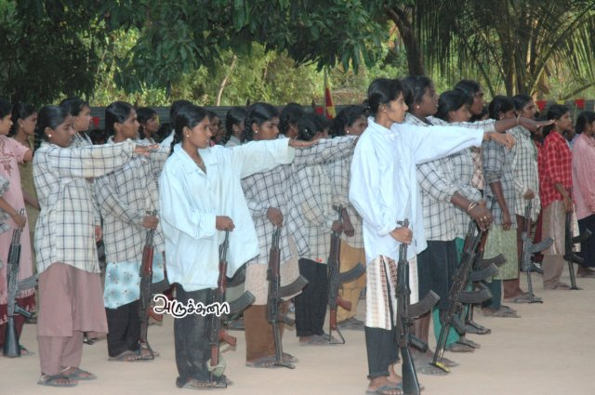 FIG. 3 & 4 – Makkal Padai or Peoples’ Militia in training, probably during ceasefire period circa 2005/06
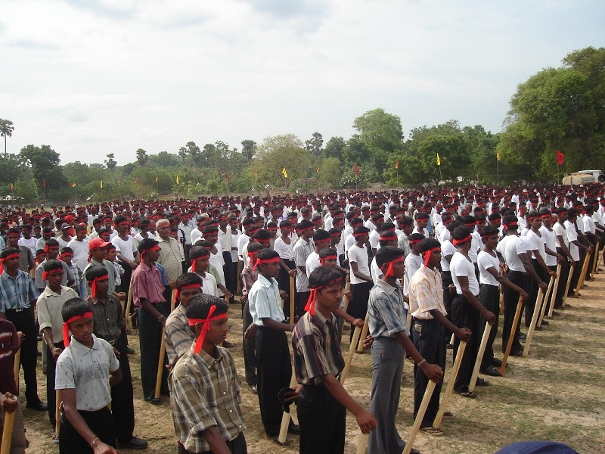

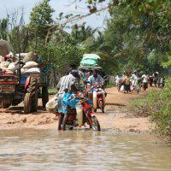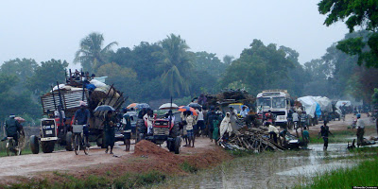
Figs. 5 & 6 – Multiple Displacements for most of the Tamil populace – Pics from a Tamil web site and en. wikipedia.org
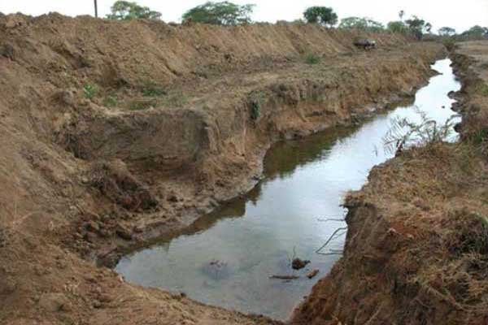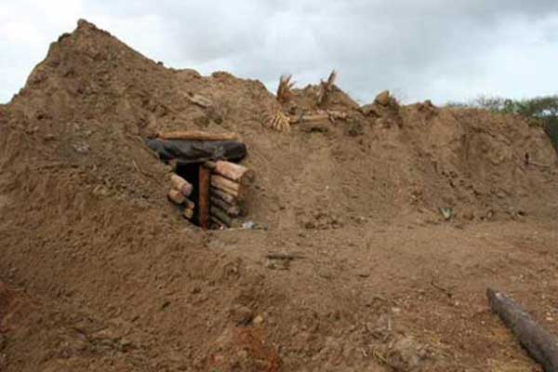
Figs. 7 & 8 – LTTE Berms built on extensive scale, sometimes for 15-20 kilometres, designed to halt armoured vehicles and hinder advancing troops – From Ministry of Defence web site
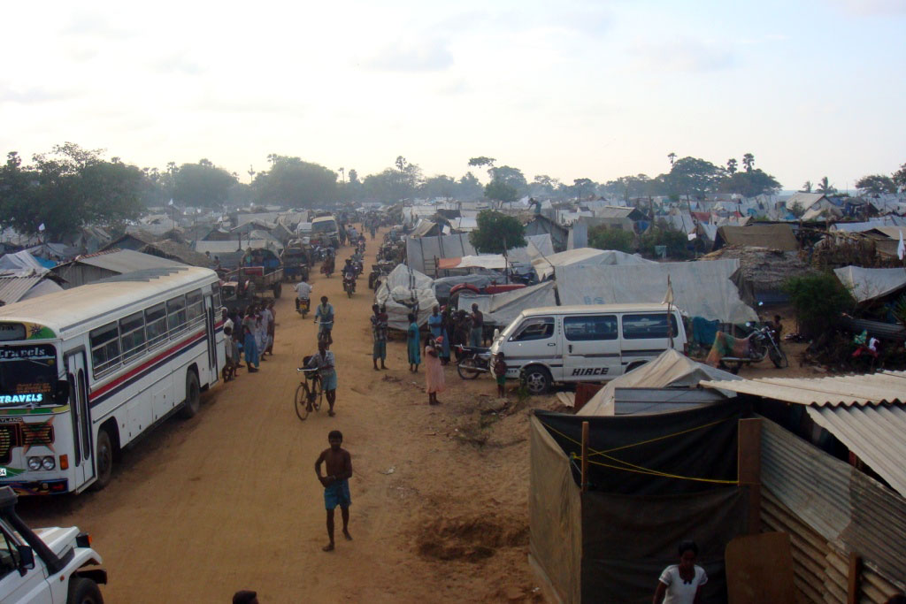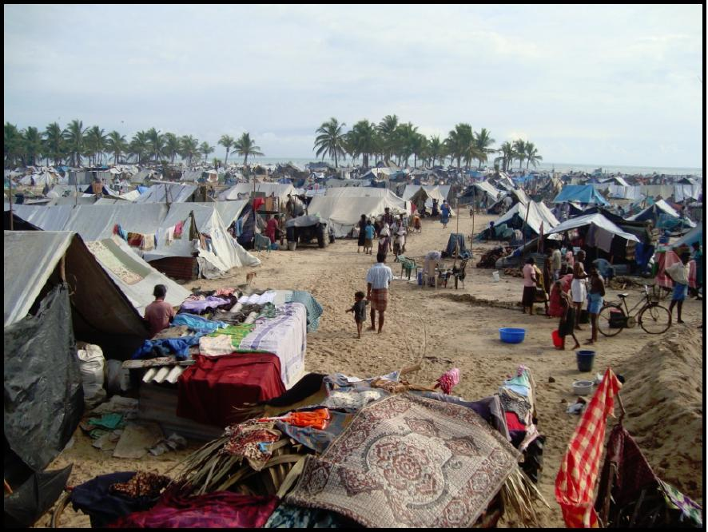
Figs. 9 & 10 = Congested main road running north-south in NKL or Last Redoubt – Pic from TamilNet, 29 March 2009 and A Tent City in one locality, one of many, in the NKL – Pic from UNoPE Report, no date

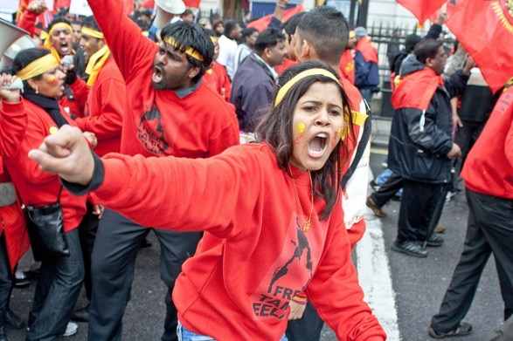 Fig. 11= Tamil demonstration – Pic from Colombo Telegraph
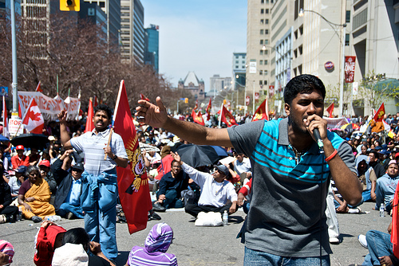
Fig. 12 = Demonstration in Streets of Toronto –from www.transcurrents.com

